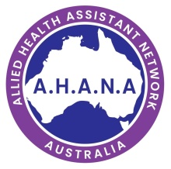
A.H.A.N.A
Allied Health Assistant Network of Australia

AHANA’s vision is to support, promote and advocate for Allied Health Assistants across Australia now and into the future.
In order to achieve our vision, AHANA aims to:
- Be a central advocacy body for peer support, research, professional development, career pathways, consultation and benchmarking.
- Enhance career opportunities and structure for Allied Health Assistants.
- Enhance skills of Allied Health Assistants (AHA) to pursue AHA careers, Allied Health professions
- Provide consultation and assistance for Allied Health Assistants.

AHANA will:
- Work with education providers to ensure more industry reflective training.
- Work with key stakeholders to further define and enhance Allied Health Assistant roles and grades.
- Provide a centralised place for industry consultation.
- Assist in the development of AHA specific professional development, job opportunities and career pathways.
AHANA has two social media pages;
Linkedin- http://www.linkedin.com/groups/13908916/
Facebook- http://www.facebook.com/groups/600711460594855
For more information related to AHAs, access AHA specific/related courses, research articles, jobs opportunities and Peer Support/Mentoring visit http://www.ahana.com.au. To join, share our network with your peers and the AHA community visit- our website (detail above) or scan our QR code.

AHANA QR code
AHANA Committee
Allied Health Assistant Network Australia
e: committee@ahana.com.au
Est: September 2020

